Lesson 1: Chapter 7 Name_______________________________Class__________________
The Renaissance
Art-
Leonardo Da Vinci- ______________________________________________________________
____________________________________________________________________________________________________________________________________________________________
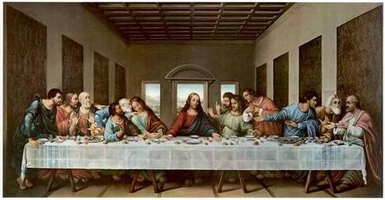
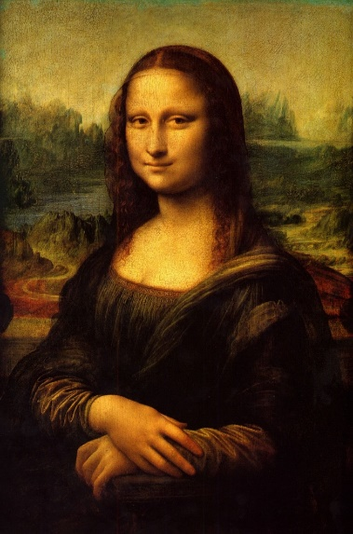

________________________________________________________________________________________________________________________________________________________________________________________________________________________________________________________________________________________________________________________
Michaelangelo- _________________________________________________________________
____________________________________________________________________________________________________________________________________________________________
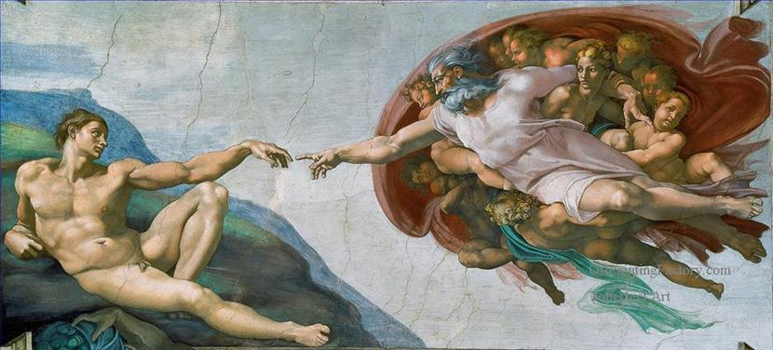

____________________________________________________________________________________________________________________________________________________________
______________________________________________________________________________

Music

Palestrina- _____________________________________________________________________
____________________________________________________________________________________________________________________________________________________________
Polyphony- ____________________________________________________________________
____________________________________________________________________________________________________________________________________________________________
Counterpoint- __________________________________________________________________
______________________________________________________________________________
______________________________________________________________________________
Video:_________________________________________________________________________
________________________________________________________________________________________________________________________________________________________________________________________________________________________________________________________________________________________________________________________

Dance

Courtdance- ___________________________________________________________________
____________________________________________________________________________________________________________________________________________________________

Theater

Commedia dell’ arte- ____________________________________________________________
____________________________________________________________________________________________________________________________________________________________
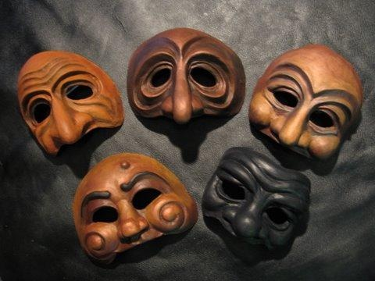

__________________________________________
__________________________________________
__________________________________________
__________________________________________

Elizabethan Theater-_____________________________________________________________
____________________________________________________________________________________________________________________________________________________________

William Shakespeare-____________________________________________________________
____________________________________________________________________________________________________________________________________________________________

